* **1 step: go to AWS Management Console –launch EC2 instance-connect to virtual machine**
* **2 step: on EC2 Dashboard select volume (EBS volume).**

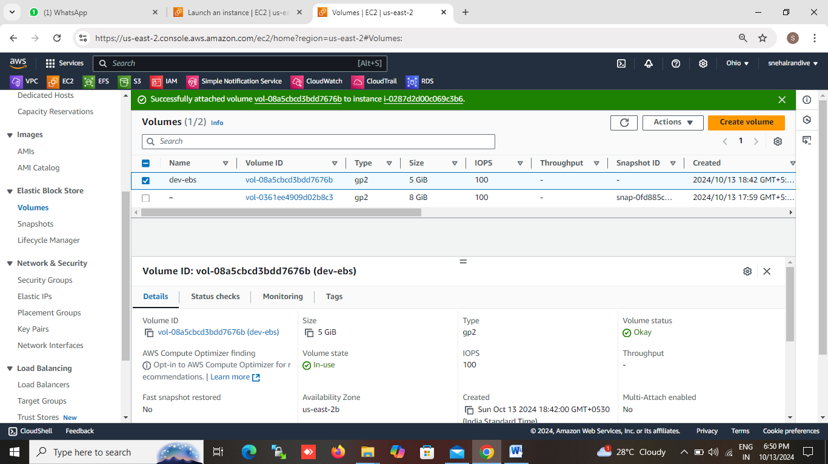

* **3 step: create volume as per the requirement and attach it to our created virtual machine**
* **4 step: select EBS volume name (/dev/xvdb) then attach it.**

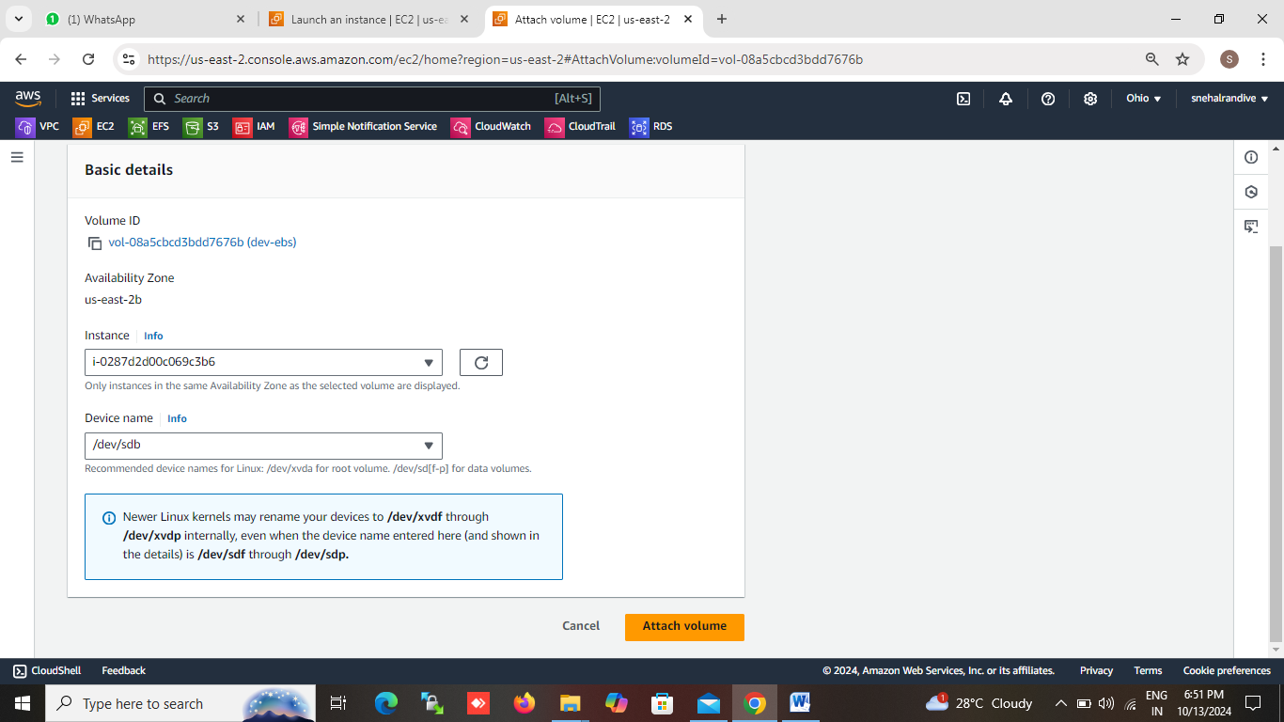

* **5 step: connect to your virtual machine and run the command to file the attached volume name. (#lsblk) .**

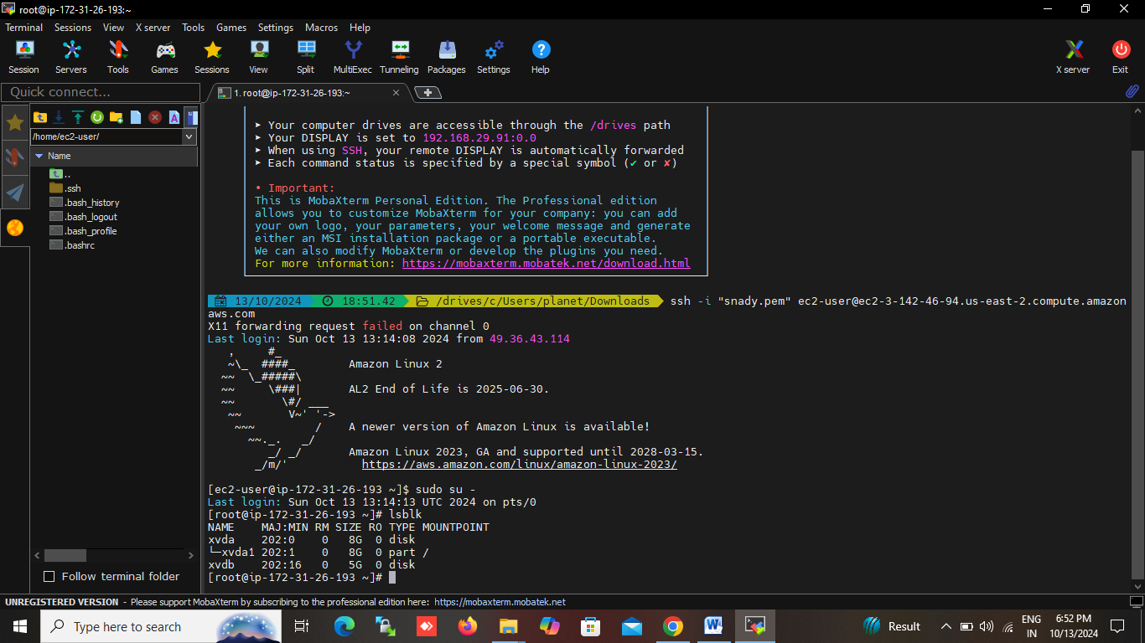

* **6 step: if it is a new volume then FORMAT it . with the help of command**

**(# mkfs –t ext4 /dev/xvdb)**

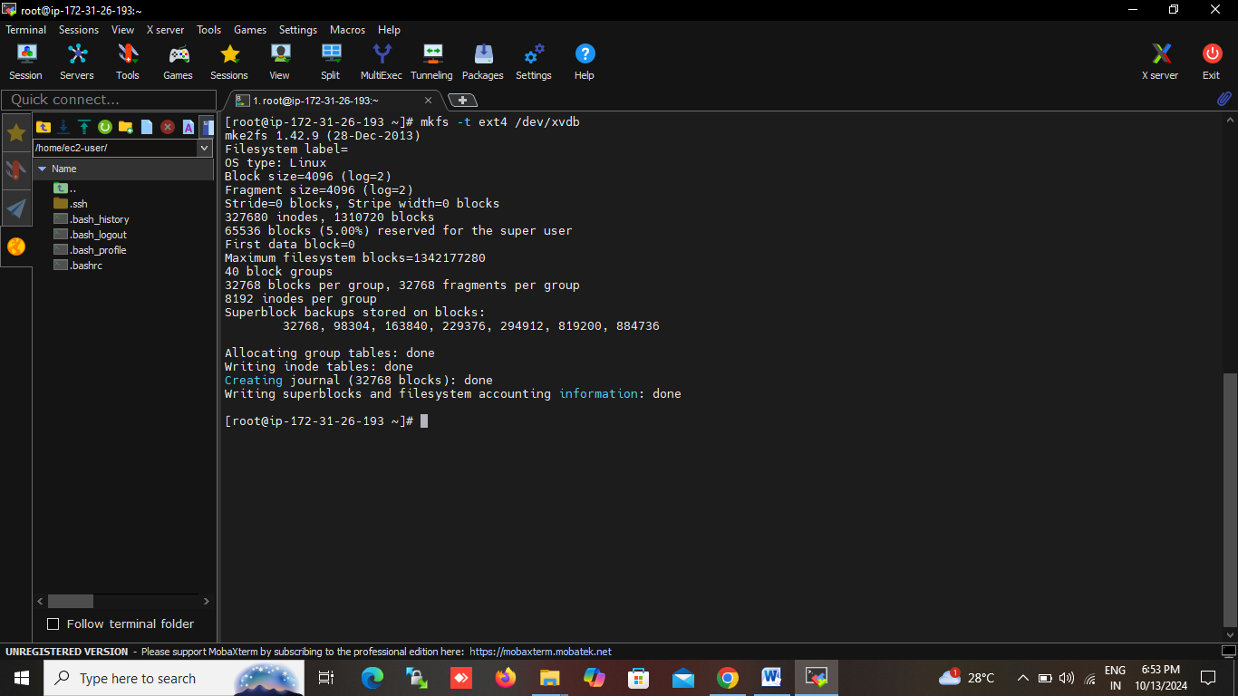

* **7 step : create mount point ,create directory to mount the volume on it .(# mkdir dirname)**
* **8 step : mount the EBS volume on that directory (# mount /dev/xvdb directory path)**
* **9 step : verify the mount using # df-h**
* **10 step : unmout or detache the volume by using command # umount /dev/xxvdb**

**(unmounts command run in other directory)**

* **11 step : then detach the volume then terminate the volume manule.**

